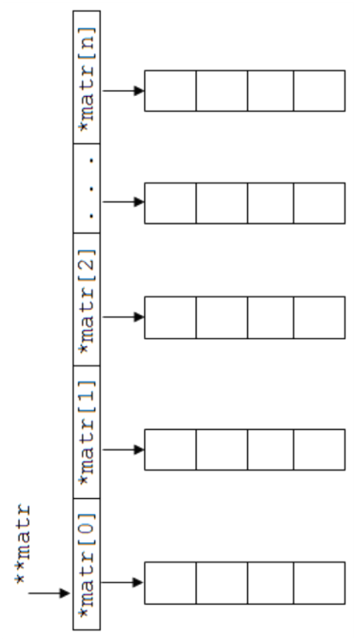
#include "stdafx.h"
#include <iostream>

using namespace std;

int main()
{
int n,m;
cin>>n>>m;

int** matr = new int *[n];
for (int i = 0; i < n; ++i)
matr[i] = new int[m];

cout<<"Enter\n";
for (int i = 0; i < n; i++)
{
for (int j = 0; j < m; j++)
{
cin>>matr[i][j];
}
}
for (int i = 0; i < n; i++)
{
for (int j = 0; j < m; j++)
{
cout<<matr[i][j]<<"\t";
}
cout<<endl;
}

for (int i = 0; i < n; i++)
delete[] matr[i];

delete [] matr;

system("pause");
return 0;
}

Mas

#include "stdafx.h"
#include <iostream>

using namespace std;

int main()
{
const int n=2;
int m;
cin>>m;

int* Mas[n];
for (int i = 0; i < n; ++i)
Mas[i] = new int[m];

cout<<"Enter\n";
for (int i = 0; i < n; i++)
{
for (int j = 0; j < m; j++)
{
cin>>Mas[i][j];
}
}
for (int i = 0; i < n; i++)
{
for (int j = 0; j < m; j++)
{
cout<<Mas[i][j]<<"\t";
}
cout<<endl;
}

for (int i = 0; i < n; i++)
delete[] Mas[i];

delete [] matr;

system("pause");
return 0;
}

